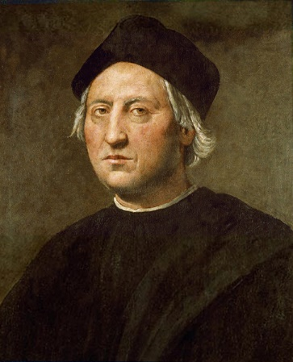

Columbus

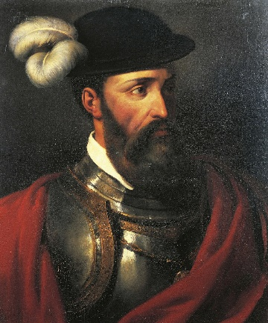

Pizarro

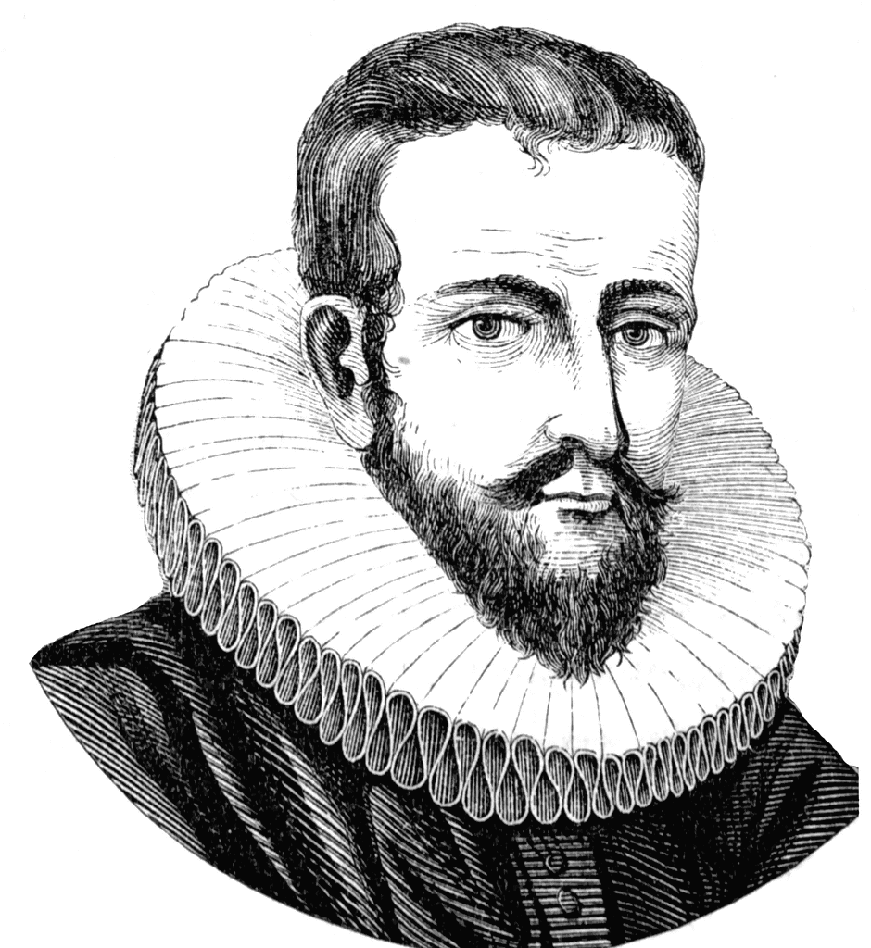

Hudson

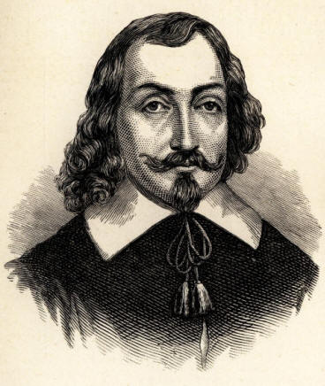

DeChamplain

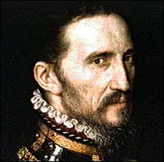

Corando

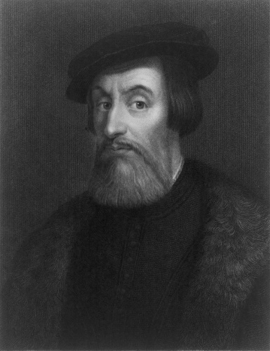

[This Photo](http://en.wikipedia.org/wiki/File:Cortes-Hernando-LOC.jpg) by Unknown Author is licensed under [CC BY-SA](https://creativecommons.org/licenses/by-sa/3.0/)

Cortes